9th June 2026

1)Creating 3 different files
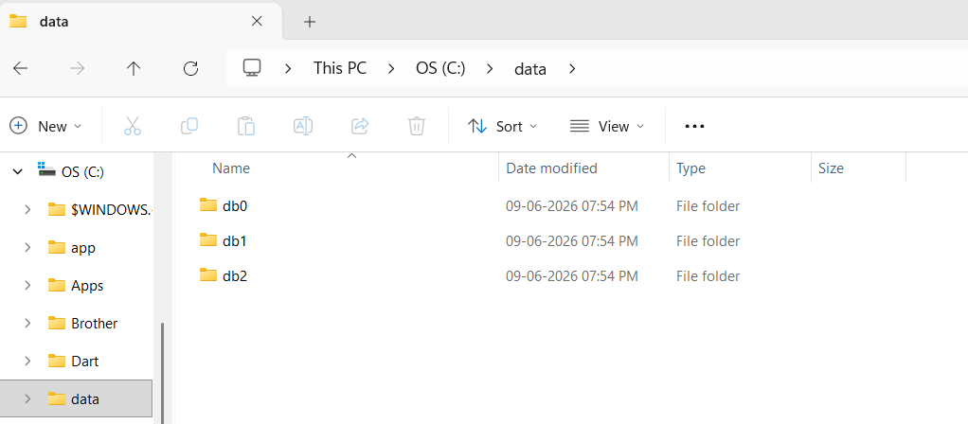

2)Instance for db0
C:\Program Files\MongoDB\Server\8.3\bin\mongod.exe" --replSet myReplSet --dbpath C:\data\db0 --port 27017 --bind_ip localhost
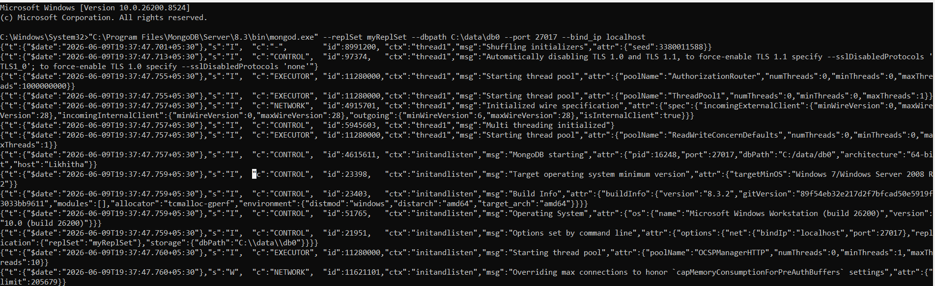

Instance for db1
C:\Program Files\MongoDB\Server\8.3\bin\mongod.exe" --replSet myReplSet --dbpath C:\data\db1 --port 27017 --bind_ip localhost
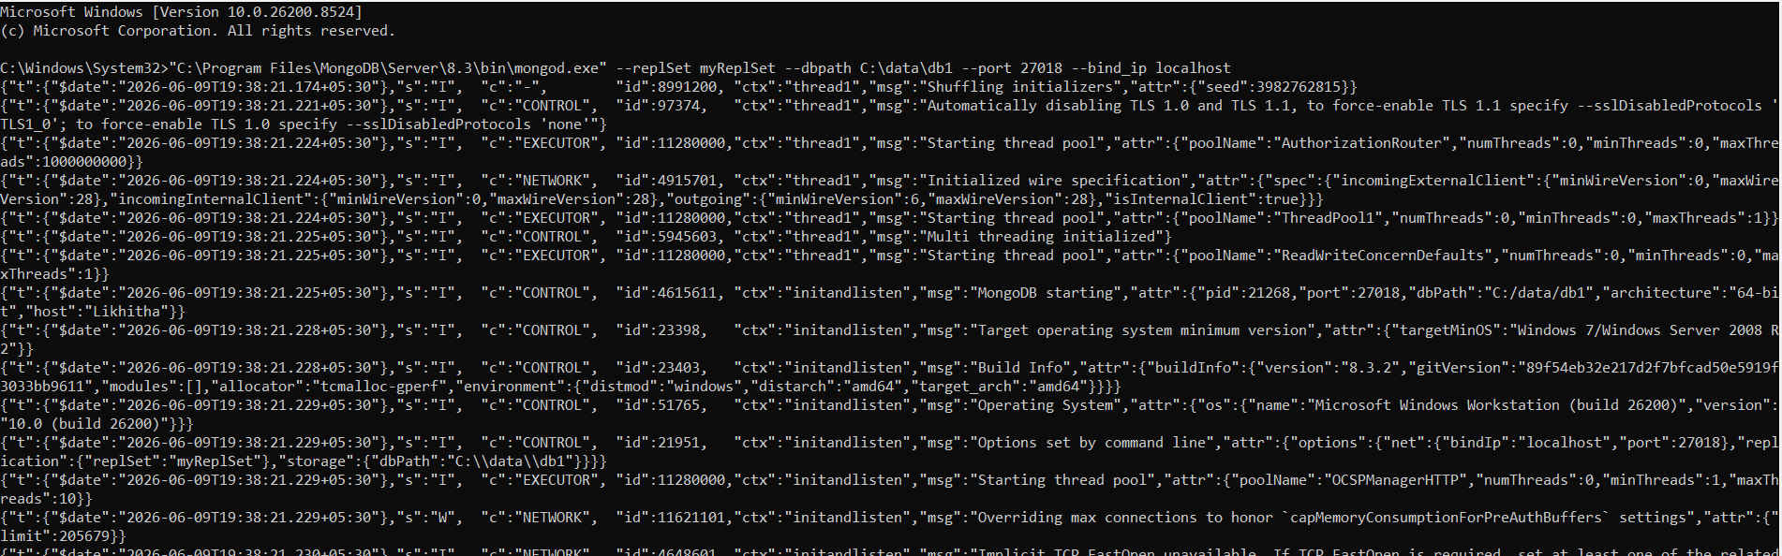

Instance for db2
C:\Program Files\MongoDB\Server\8.3\bin\mongod.exe" --replSet myReplSet --dbpath C:\data\db2 --port 27017 --bind_ip localhost
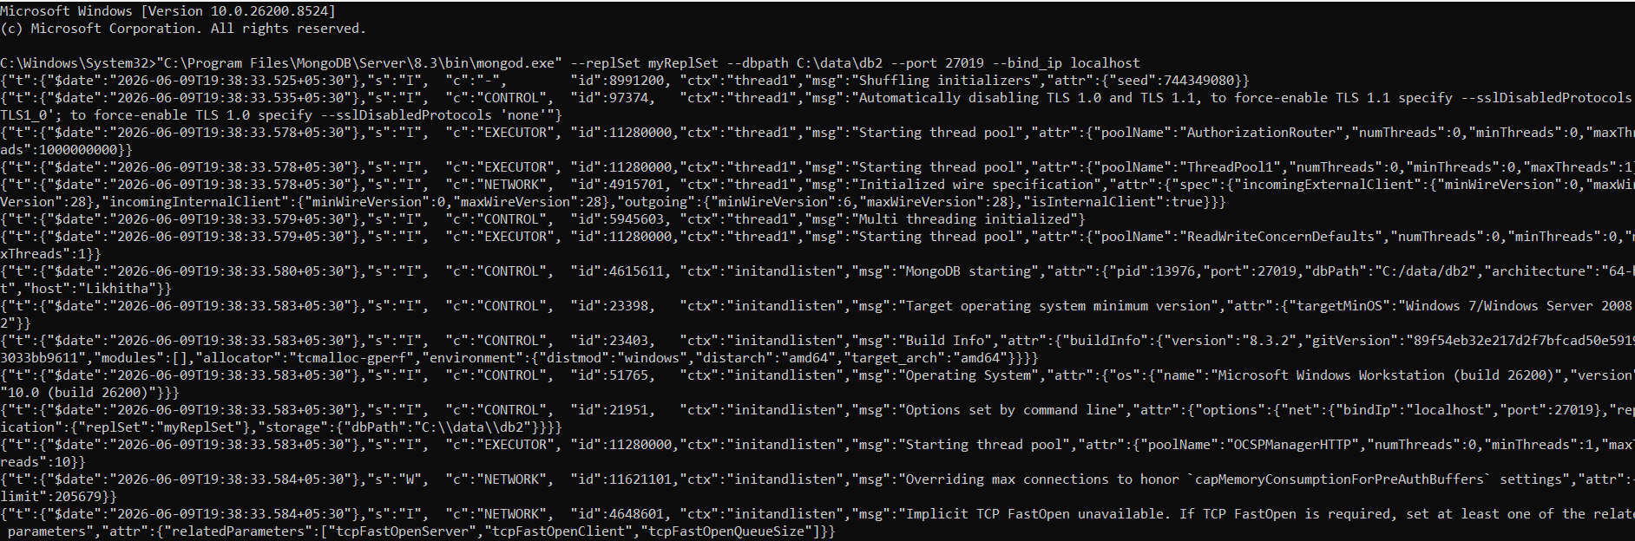

MongoDb compass
Connecting Compass
URL:
mongodb://localhost:27017

Output:
